**ARCHITRAVE & ROUND Manual**

**Proximity switch for activation and access control**

Hard coated, scratch resistant, anti‐reflective, anti‐microbial Steritouch acrylic label

Entire label is sensitive

[www.quantek.co.uk](http://www.quantek.co.uk) 01246 417113



Ascertain the ﬁxing height.

Use the back plate to mark cable hole and screw ﬁxing points, round unit can be angled towards approaching users.

Fix the top retaining screw (No 8 or 10) leaving 4mm of screw shaft protruding.

Fit the back seal to the rear of back plate (if being installed externally)

Place the cable through back plate and make connections (see below) or connect battery clip and program to receiver (see next page).

Place the back plate in position, hook unit onto the top retaining

screw and ﬁt the bottom retaining screw.

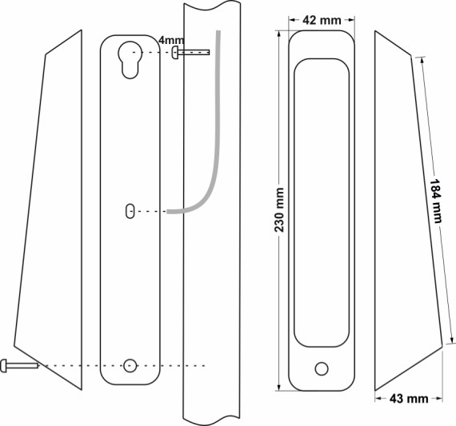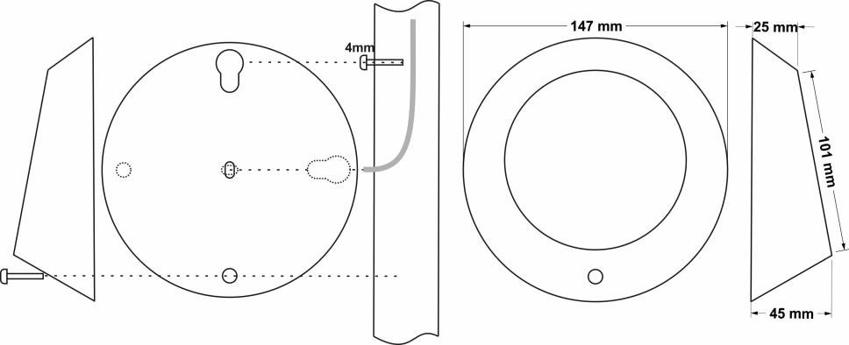

Architrave

Round

**Hardwired specification:**

12 – 28v dc

8mA (standby) / 35mA (max) +18mA LEDs

Sensitivity - Touch - up to 70mm hands free

Selectable red, green, blue LEDs

Sounder on activation

Timer 1 - 27 seconds

Latching function

# Wiring diagrams

**Hardwired sensor wiring. Alter LED colour configuration as required.**

12-28Vdc +V

NO activate 0V return

0V

12-28Vdc +V

NO activate 0V return

0V

### Normally open contacts. 0v return Normally open contacts. +v return

12-28Vdc

NO activate

+V return

0V

12-28Vdc

NO activate

0V return

0V

**

12-28Vdc +V

NO activate 0V return

0V

12-28Vdc +V

NO activate 0V return

0V

**Remote switch**

N.O.

(Optional)

**Latch jumper**

Momentary

Latching

**Sounder**

**Sensitivity dip-switches**

1 - Low

4 - High

Remove power

alter range

re power

**Timer**

1-27 seconds

Anti-clockwise to increase time

**Note:** Never connect anything to RD terminal

12-28Vdc +V

NO activate 0V return

0V

**Radio programming (RX-2)**

Supply receiver with 12/24Vdc, power LED will light if powered correctly

Wire relay outputs to activate terminals on the system (clean, normally open contacts) Press and release the learn button, the learn LED will light up for 10 seconds

Within the 10 seconds operate the touch sensor

The learn LED will flash to confirm it has programmed

### Note: Standard touch sensors program to channel 1. The RX‐T receiver will be required if you need to program them to different channels.

It is also possible to program our handheld and desk mount transmitters (CFOB, FOB‐M, FOB4‐M, DDA1, DDA2) into this receiver using the same method. See transmitter box for more details

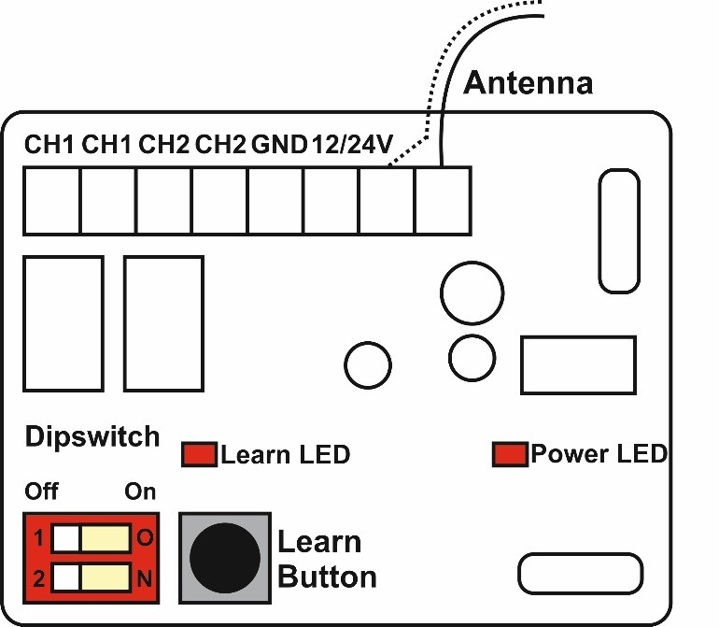**Reset:** To reset the receiver, press and hold the learn button for 10 seconds until the learn LED starts flashing. After this the memory will be deleted

**Radio specification**

868MHz

4 x AA batteries

Approximately 100,000 operations Sounder & green LED on activation

Battery saving design, unit will only activate once if hand left on

## Receiver specification

12/24Vdc supply 868MHz

2 channels

1A 24Vdc normally open contacts Momentary/bi‐stable selectable relays

|  |  |  |
| --- | --- | --- |
| **Dipswitch settings** | | |
|  | ON | OFF |
| 1 | CH1 ‐ Bi‐Stable | CH1 ‐ Momentary |
| 2 | CH2 ‐ Bi‐Stable | CH2 ‐ Momentary |

200 code memory

Dimensions: 65 x 50 x 30 mm