KPN-2
The KPN-2 is a waterproof dual relay access control unit with integrated keypad and card/fob reader. Two relays make it ideal for switching a main gate & pedestrian gate.
It is suitable for mounting either indoors or outdoors in harsh environments. It is housed in a strong, sturdy and vandal proof zinc alloy powder coated case.
This unit supports up to 999 users in multiple access configurations (card only, PIN only, or card + PIN). Both relays can operate in pulse mode (1-300 seconds) or toggle mode.

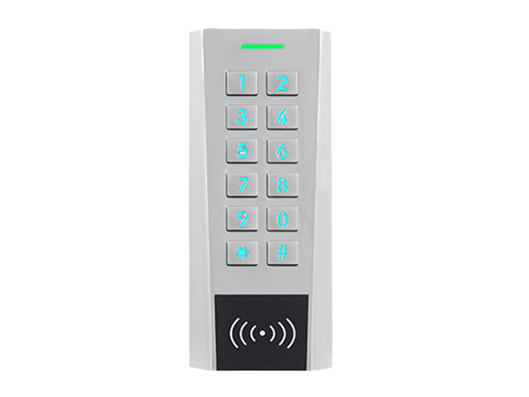
- Supports wide voltage input 12-28Vac/dc
- Waterproof, conforms to IP66
- Strong zinc alloy powder coated anti-vandal case
- Card frequency: 125KHz EM
- Read range: 1-6cm
- All metal keys
- Full programming from the keypad
- 2 relays
- 999 users, supports card, PIN, or card + PIN
- PIN length 1-8 digits
- Backlit keys, set always on, always off, or automatically off after 60 seconds
- Multi-colour LED status display
- Integrated alarm and buzzer output, can set volume level 0 - 5
- Pulse or toggle mode
- Built in light dependent resistor (LDR) for anti-tamper
- Pre-wired with 1 metre of cable
- Dimensions: 134 x 55.5 x 21mm
- Operating temperature: -40 to 60⁰C

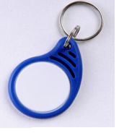
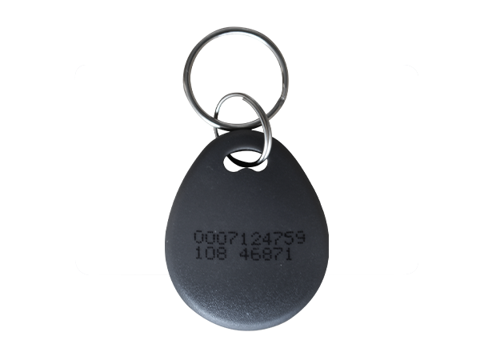
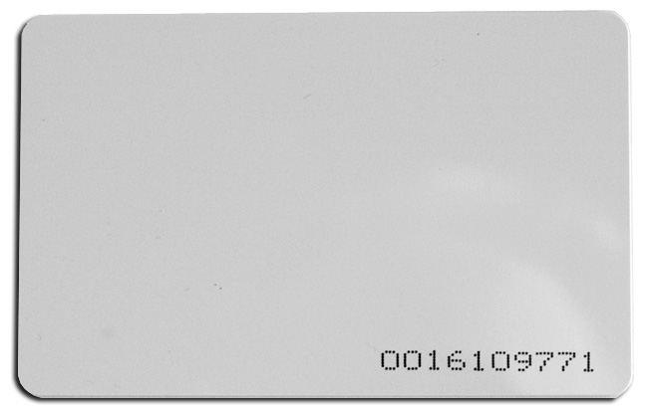
Accessories:
PCARD
PFOB-IP
PFOB-G

